# **Primary Color**

#2d69c9

'mariner': {

'50': '#f0f8fe',

'100': '#deeefb',

'200': '#c4e2f9',

'300': '#9cd1f4',

'400': '#6db6ed',

'500': '#4b99e6',

'600': '#367dda',

**'700': '#2d69c9',**

'800': '#2a56a3',

'900': '#274981',

'950': '#1c2e4f',

},

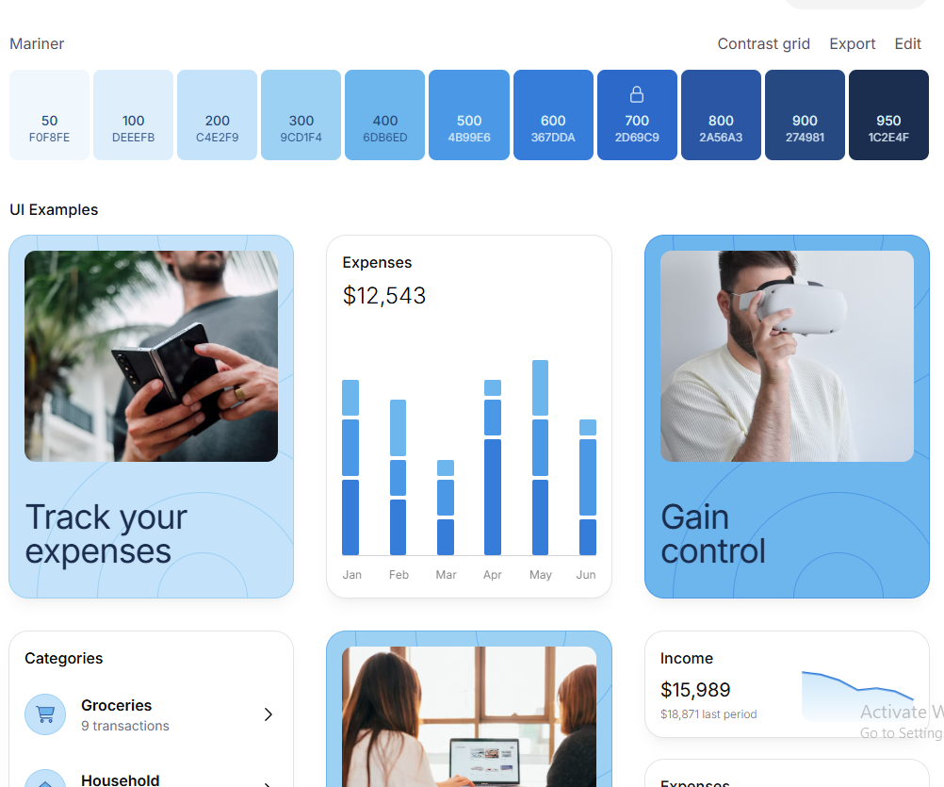

# **Secondary Color**

#13823c



'malachite': {

'50': '#f0fdf4',

'100': '#dbfde7',

'200': '#baf8d0',

'300': '#84f1ab',

'400': '#47e17e',

'500': '#22dd6699',

'600': '#13a648',

'700': '#13823c',

'800': '#146734',

'900': '#13542d',

'950': '#042f16',

},

# **Background Color**

'athens-gray': {

**'50': '#f5f7fa',**

'100': '#eaeef4',

'200': '#d0dae7',

'300': '#a7bbd2',

'400': '#7897b8',

'500': '#577aa0',

'600': '#446285',

'700': '#38506c',

'800': '#31445b',

'900': '#2d3b4d',

'950': '#1e2733',

},

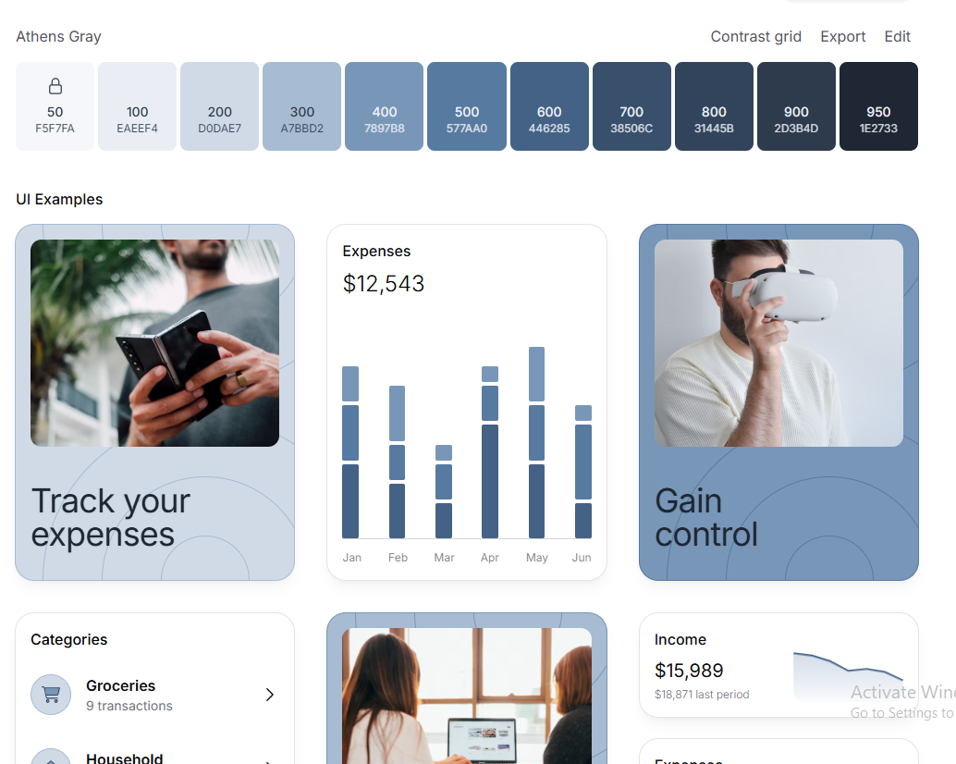

# **Complementary Color**

'hibiscus': {

'50': '#fcf3f8',

'100': '#fbe8f3',

'200': '#f9d1e7',

'300': '#f4add3',

'400': '#ed79b4',

'500': '#e35197',

**'600': '#c92d70',**

'700': '#b5215d',

'800': '#951f4c',

'900': '#7d1e43',

'950': '#4c0b24',

},

